**ARDUINO LED PROJECT**

**Serial Communication(RECEIVE)**

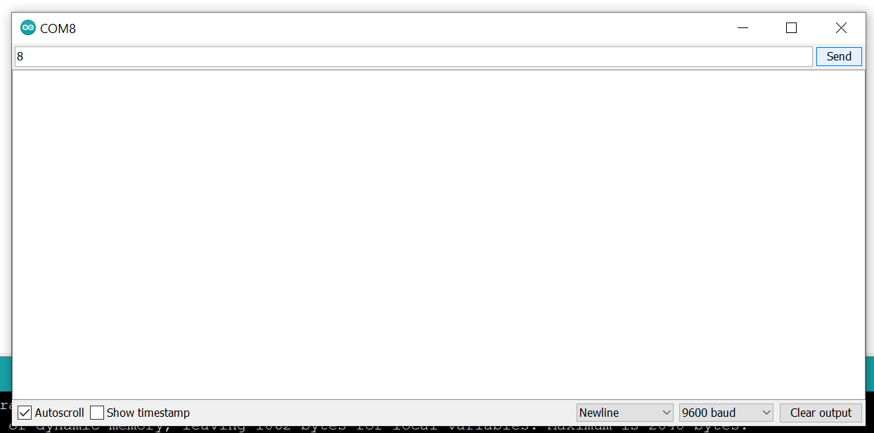

For this project we will need:

* Arduino board.

Circuit Design:

1. First make sure that the Arduino is powered off on.
2. Upload the following sketch to your arduino

|  |
| --- |
| const int ledpin = 13;  int blinkRate = 0;  void setup() {  Serial.begin(9600);  pinMode(ledpin, OUTPUT);  }  void loop(){  if ( Serial.available()){ //condition  char ch = Serial.read();  if( ch >= '0' && ch <= '9'){  blinkRate = ch-'0';  blinkRate = blinkRate * 100; //state  }  }  blink();  }  void blink(){  digitalWrite(ledpin, HIGH);  delay(blinkRate);  digitalWrite(ledpin, LOW);  delay(blinkRate);  } |

const int ledPin;

int blinkRate=0;

const shows the value assigned will not be changed.It alsoprevents the value from being reassigned.

int shows the value is a number. Values declared without the keyword const can be modified later in the program execution.

Serial.begin(9600);

This initializes communication via serial communication port. This provides the user an interface to interact with the program during execution.

pinMode(ledpin, OUTPUT);

This assigns the led to be used .This is also the pin attached to the onboard LED.

if ( Serial.available()){

Sets a condition. The program will run the following block when it receives input from the user through the serial monitor. This allows the user input values during program execution. This can then be used to modify the state,which is the blink rate which is initially set to 0 ie off.

blinkRate = ch-'0';

blinkRate = blinkRate * 100;

This gets the value which is an integer after the subtraction operation.

Then the value is multiplied by 100. Since the value passed to delay is in milliseconds ,we multiply the value by 100 to make the change in state more visible,noticeable.

blink()

This tells the program that this refers to a set of instructions that has been declared. This predetermined way to handle the data is looked for in the program memory. Then the instructions are executed as declared

void blink(){

This creates a block of instructions which can then be reused in other sections of the program without the need to repeat writing out the set of instructions.

digitalWrite(ledpin, HIGH);

delay(blinkRate);

digitalWrite(ledpin, LOW);

delay(blinkRate);

This instructions will be executed when blink() is met during program execution.

Turn on LED for the duration set by the user.

Turn off LED for the duration set by the user.

void setup (){}

This initializes the arduino and assigns functionality to its pins.

This also provides required resources for monitoring.

void loop(){}

After executing the void setup() function, we enter the void loop() and this function is executed continuously and repeatedly, until you Arduino is powered off.